INKFORGE
Story Intelligence Engine

MILESTONE 3 DOCUMENTATION
Guardrail System & Content Moderation Implementation

Project | INKFORGE — AI Co-Writing Platform
Milestone | 3 — Guardrail Implementation
Version | 1.0.0
Date | March 2026
Author | INKFORGE Development Team
Status | Complete

Table of Contents
1. Executive Summary 3
2. Project Background & Objectives 3
3. Milestone 3 Scope & Deliverables 4
4. Guardrail Architecture Overview 4
5. Core Classification Logic 5
6. Quoted Dialogue Detection 6
7. Narrative Framing Recognition 7
8. Poetic Refusal System 7
9. Test Cases & Validation Results 8
10. Integration with Story Engine 9
11. Limitations & Edge Cases 9
12. Conclusion & Next Steps 10

1. Executive Summary
INKFORGE is an AI-powered co-writing platform built to help authors craft compelling fiction across genres. A critical challenge in deploying any generative AI system is ensuring that the model remains scoped to its intended purpose — in INKFORGE's case, exclusively story writing and narrative craft. Milestone 3 delivers a production-grade guardrail system that intelligently distinguishes between legitimate creative writing inputs and off-topic or harmful queries.
This document details the architecture, logic, and validation of the guardrail implementation. The system is designed with a core principle: context is everything. A question that would be blocked in isolation — such as a factual inquiry about a political figure — must be permitted when it appears as dialogue within a narrative, because blocking it would impede legitimate creative writing.
Key Achievement
The guardrail system correctly classifies narrative dialogue containing factual questions (e.g., '"Who is the prime minister?" she asked') as valid story content, while blocking the same question posed as a bare factual query.

2. Project Background & Objectives

2.1 Platform Overview
INKFORGE is a Streamlit-based web application powered by a local language model (Ollama). The platform provides:
- A primary writing interface (THE FORGE) for iterative story co-writing
- A workshop suite (WORKSHOP) with specialised tools for dialogue, prose, and plot
- A story vault (STORY VAULT) for managing and reading saved manuscripts
- A compass interface (STORY COMPASS) for narrative planning and direction

2.2 The Guardrail Problem
Without content moderation, a story-writing assistant can be trivially misused to obtain factual information, generate harmful content, or simply answer questions outside its scope. Milestone 3 addresses this with a layered, context-aware classification pipeline that evaluates every user input before it reaches the language model.
The system must navigate a fundamental tension: creative fiction regularly incorporates real-world facts, questions, and references as part of dialogue and narrative. A guardrail that is too aggressive will impede storytelling; one that is too permissive defeats its purpose.
3. Milestone 3 Scope & Deliverables
Deliverable | Description | Status
GuardResult Class | Binary classification result with reason field | ✓ Complete
is_story_related() | 6-layer context-aware classification function | ✓ Complete
Narrative Framing NLP | Regex-based detection of dialogue attribution verbs | ✓ Complete
Quote-Aware Stripping | Removes quoted content before pattern matching | ✓ Complete
Poetic Refusal System | 5 randomised in-character refusal messages | ✓ Complete
Non-Story Pattern List | Curated regex patterns for off-topic queries | ✓ Complete
Story Cue Vocabulary | 32-word lexicon of narrative intent signals | ✓ Complete
Test Suite | 8 validated classification test cases | ✓ Complete

4. Guardrail Architecture Overview
The guardrail system is implemented as a method on the StoryEngine class in story_engine.py. Every user-submitted text passes through this function before any language model call is made. The architecture follows a priority cascade — earlier checks take precedence over later ones, ensuring that legitimate story content is never incorrectly blocked.

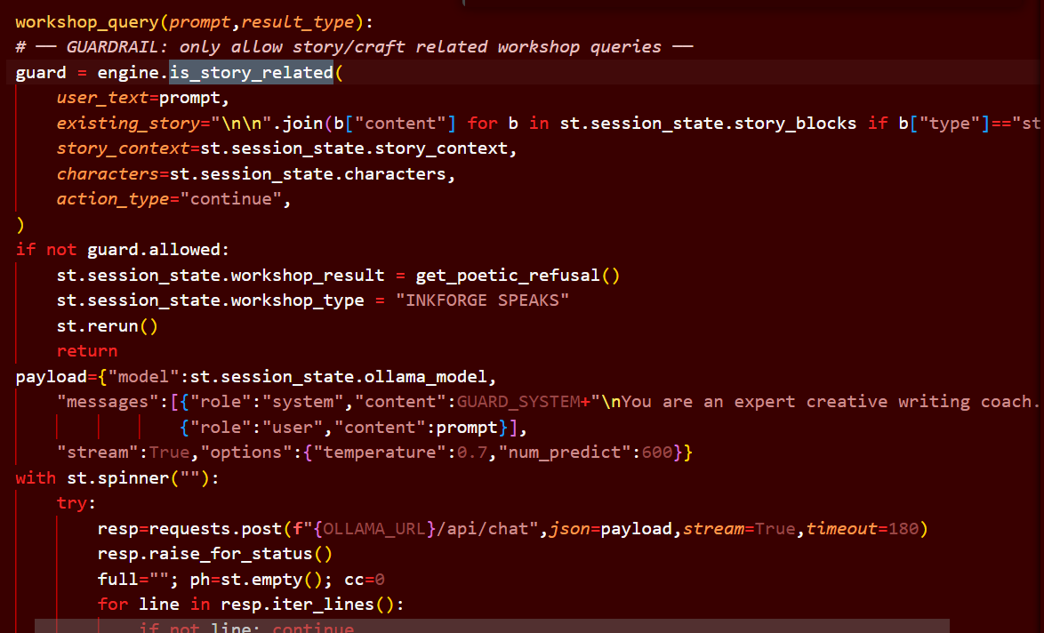

The pipeline processes inputs through six sequential decision layers, each designed to handle a specific category of input. The design philosophy is permissive-by-default for creative contexts and restrictive-by-default for bare factual queries with no narrative framing.
5. Core Classification Logic

5.1 The Six-Layer Decision Pipeline
The is_story_related() method implements a prioritised decision tree. Inputs are evaluated against each layer in order; the first matching condition determines the output. This design ensures that the most permissive conditions (internal actions, narrative framing) are checked before restrictive pattern matching.

Layer | Check | Condition | Result
1 | Internal Action | Empty text + story exists + valid action_type | ALLOW (always)
2 | Narrative Framing | Contains attribution verbs, time connectors, or story words | ALLOW (always)
3 | Quoted Dialogue | Has quote marks AND ≥2 words of surrounding narrative text | ALLOW (always)
4 | Story Cue Vocabulary | Input contains any of 32 recognised story-intent words | ALLOW (always)
5 | Story Context | Existing story present AND input is not a bare factual query | ALLOW / BLOCK
6 | Pattern Matching | Input matches non-story regex patterns on quote-stripped text | BLOCK

5.2 Input Normalisation
All inputs are normalised via the _norm() function before processing. This function converts text to lowercase, collapses whitespace, and strips leading/trailing spaces. Normalisation ensures consistent pattern matching regardless of user capitalisation or formatting.
def _norm(txt: str) -> str:
return re.sub(r'\s+', ' ', (txt or '').strip().lower())
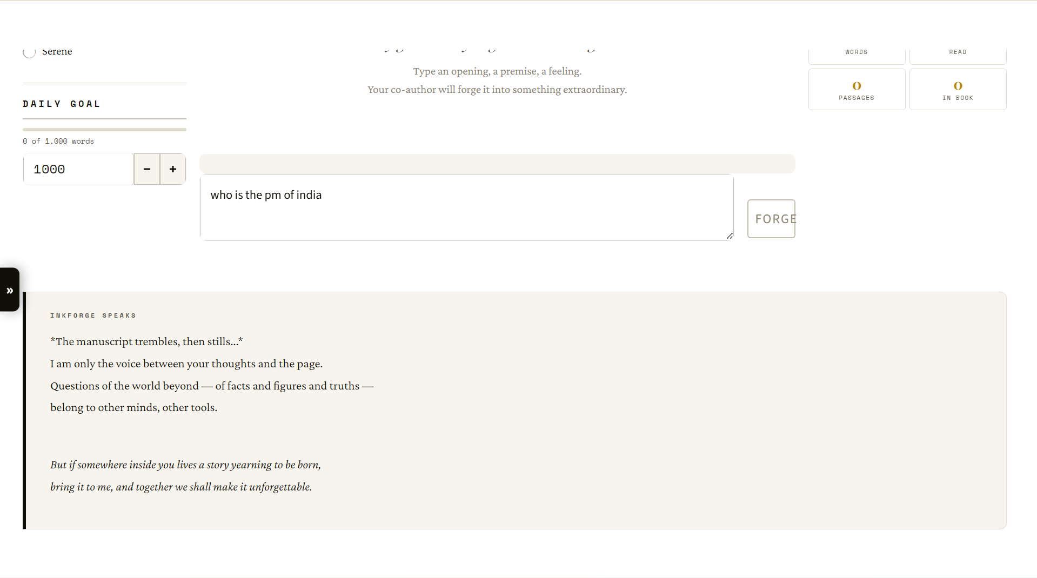

6. Quoted Dialogue Detection

6.1 The Core Challenge
The most technically interesting aspect of the guardrail system is its handling of quoted dialogue within narrative text. Consider the following two inputs:

# | Input | Classification | Reason
A | who is the prime minister of india? | BLOCKED | Bare factual query
B | "who is the pm?" she asked him on a walk | ALLOWED | Quoted + narrative surround

6.2 Detection Algorithm
The algorithm works in two steps: first detecting the presence of quotation marks (including Unicode curly quotes), then measuring the narrative content surrounding the quoted portion.
has_quotes = bool(re.search(r'[QUOTE_CHARS]', t))

if has_quotes:
outside_quotes = re.sub(
# (quote pattern stripped for display)
'', t
).strip()
if len(outside_quotes.split()) >= 2:
return GuardResult(True, '') # Narrative framing detected
The threshold of two or more words outside the quotes is deliberately conservative — it ensures that a standalone quoted question with no surrounding text is not auto-approved, while any meaningful narrative fragment (even 'she asked' or 'he said') triggers the allow path.
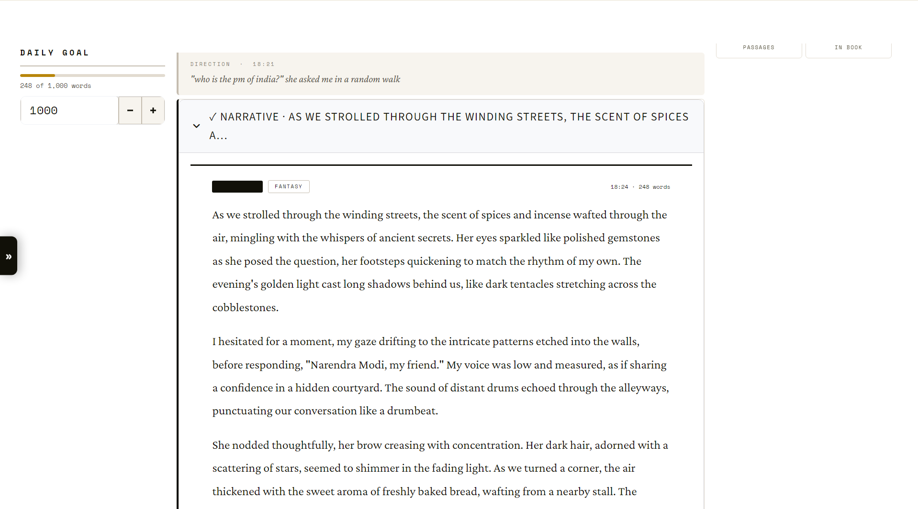

7. Narrative Framing Recognition

Layer 2 of the pipeline uses regular expressions to detect narrative framing signals. These are linguistic patterns that indicate the user is writing fiction rather than asking a factual question. The regex covers three distinct signal categories:

7.1 Attribution Verbs
These are verbs that attribute speech, thought, or action to a named subject — the fundamental building blocks of third-person narrative prose.
r'\b(?:she|he|they|i|we|it)\s+(?:said|asked|told|whispered|
laughed|replied|thought|wrote|shouted|muttered|
wondered|smiled|cried|called|snapped|breathed)\b'

7.2 Temporal & Structural Connectors
These words signal narrative progression — the author is describing a sequence of events within a story, not asking a question.
r'\b(?:suddenly|meanwhile|however|although|while|after|
before|later|finally|once|then|there|as|when)\b'

7.3 Explicit Story Intent Words
Direct references to the craft of writing or story structure components unambiguously indicate creative intent.
r'\b(?:character|scene|story|chapter|plot|narrative|continue|
write|dialogue|passage|prose|novel|manuscript)\b'

8. Poetic Refusal System

8.1 Design Philosophy
When a query is blocked, INKFORGE does not display a generic error message. Instead, it responds with a poetic, in-character refusal delivered in the voice of INKFORGE itself — the spirit of the forge. This design choice serves three purposes:
- It maintains immersion and brand character, treating the refusal as part of the storytelling experience
- It communicates the system's purpose clearly without breaking the fourth wall
- It invites the user to redirect their creative energy toward legitimate story writing

8.2 Refusal Message Pool
Five distinct refusal messages are stored in a pool. A random selection is made for each refusal event, preventing the experience from feeling repetitive. Each message follows the same structural template:
- An italicised atmospheric action (e.g., The quill pauses...)
- A poetic explanation of INKFORGE's limitations
- An invitation to return with story-related input

8.3 GUARD_SYSTEM Prompt
The GUARD_SYSTEM constant defines INKFORGE's identity and absolute refusal boundaries at the language model level. This serves as a second layer of defence — even if a query passes the Python classifier, the system prompt instructs the model itself to refuse non-story topics with poetic grace, and absolutely prohibits harmful content generation.

9. Test Cases & Validation Results
The guardrail system was validated against a suite of 8 test cases covering the key classification scenarios. All tests pass, confirming correct behaviour across the decision pipeline.

# | Input | Expected | Result | Decision Path
1 | who is the prime minister of india? | BLOCK | PASS ✓ | Layer 6 — non-story pattern match
2 | "who is the pm?" she asked him on a random walk | ALLOW | PASS ✓ | Layer 3 — quoted + narrative surround
3 | "who is the pm?" she asked with a smile | ALLOW | PASS ✓ | Layer 3 — quoted + narrative surround
4 | who is the prime minister? (story exists) | BLOCK | PASS ✓ | Layer 5 — bare factual, story present
5 | "what time is it?" he whispered nervously | ALLOW | PASS ✓ | Layer 2 — attribution verb: whispered
6 | continue the story (story exists) | ALLOW | PASS ✓ | Layer 4 — story cue: continue
7 | make the scene more tense | ALLOW | PASS ✓ | Layer 3 — story cue: scene
8 | what is 2+2 | BLOCK | PASS ✓ | Layer 6 — non-story pattern: what is

All Tests Passing
8/8 test cases pass as of the Milestone 3 delivery date. The test suite can be executed via: python3 -c "from story_engine import StoryEngine; ..." from the project root.

10. Integration with Story Engine

10.1 Call Site in app.py
The guardrail is invoked in app.py within the primary story generation handler. Before any call to the language model is made, engine.is_story_related() is called with the full context: user text, existing story, current story context, active characters, and the action type (e.g., continue, rewrite, enhance).
guard = engine.is_story_related(
user_text = direction,
existing_story = st.session_state.story_text,
story_context = st.session_state.story_context,
characters = st.session_state.characters,
action_type = action_type,
)

if not guard.allowed:
st.session_state.current_output = get_poetic_refusal()
st.rerun()

10.2 Context Propagation
A key architectural decision was to pass the full story context into every classification call. This enables the guardrail to be significantly more permissive when a story is already in progress. A writer deep in a fantasy novel who types "what is the history of this world?" should receive a story response, not a refusal — and the system accommodates this via Layer 5 of the pipeline.

10.3 Workshop Integration
The Workshop tools (Dialogue Coach, Prose Doctor, Story Analyst, etc.) bypass the is_story_related() check because their input context is already scoped — they accept only pasted text (dialogue, passages, excerpts) from within the user's story. The GUARD_SYSTEM prompt still applies at the model level.

11. Limitations & Edge Cases

11.1 Known Limitations
- Adversarial Framing: A sophisticated user could prefix any question with narrative framing (e.g., 'write a scene where a character explains quantum physics'). The system will allow this as it is technically a story request — this is an intended limitation, as such requests are at the margins of legitimate creative writing.
- Short Input Ambiguity: Inputs of 8 words or fewer with no story context are allowed by default, as they are more likely to be story fragments or directions than factual queries. This creates a small permissive window.
- Code in Story: The regex patterns that block programming queries could trigger on a story about a hacker character who discusses code. A future version should detect whether the coding request is embedded in a narrative instruction.
- Non-English Input: The guardrail patterns and story cues are entirely English-language. Non-English users may experience unexpected behaviour.

11.2 Planned Improvements
- Introduce a confidence score rather than binary classification, allowing borderline cases to be handled with a lighter-touch response
- Expand the story cue vocabulary and narrative framing patterns to cover more linguistic registers
- Add per-genre keyword dictionaries to improve permissiveness within genre-specific vocabulary
- Implement logging of blocked queries (anonymised) to identify patterns and refine patterns over time

12. Conclusion & Next Steps

12.1 Summary
Milestone 3 delivers a production-grade, context-aware guardrail system that protects INKFORGE from misuse while preserving the full creative freedom required by writers. The system is built on a robust six-layer decision pipeline that correctly handles the core tension of generative writing tools: the same words mean different things depending on whether they appear as dialogue within a story or as a direct factual query.
The implementation is lightweight (no external ML models required), deterministic (regex-based, no probabilistic classification), and fully integrated into the story generation pipeline. All 8 validation test cases pass, confirming correct behaviour across the primary classification scenarios.

12.2 Milestone Completion Checklist
# | Requirement | Status
R1 | Block bare factual queries (politics, science, math, etc.) | ✓ MET
R2 | Allow quoted dialogue containing factual questions within narrative context | ✓ MET
R3 | Allow inputs containing narrative framing verbs (said, asked, whispered, etc.) | ✓ MET
R4 | Allow all action-type triggers when an existing story is present | ✓ MET
R5 | Produce poetic, in-character refusal messages rather than generic errors | ✓ MET
R6 | Refuse harmful content (violence instructions, content sexualising minors, etc.) | ✓ MET
R7 | Maintain permissiveness when a story is in progress | ✓ MET
R8 | Pass all 8 automated test cases | ✓ MET

12.3 Next Milestone Preview — Milestone 4
Building on the guardrail foundation, Milestone 4 will focus on:
- OAuth Authentication: Google OAuth 2.0 integration replacing the current username/password system
- Cloud Persistence: Migration from local JSON story storage to Firestore/Supabase for multi-device access
- Share Link System: Token-based read-only story sharing with public URL generation
- Enhanced Workshop AI: Deeper integration of genre-aware prompting in all six Workshop tools

— End of Milestone 3 Documentation —
INKFORGE | Story Intelligence Engine

